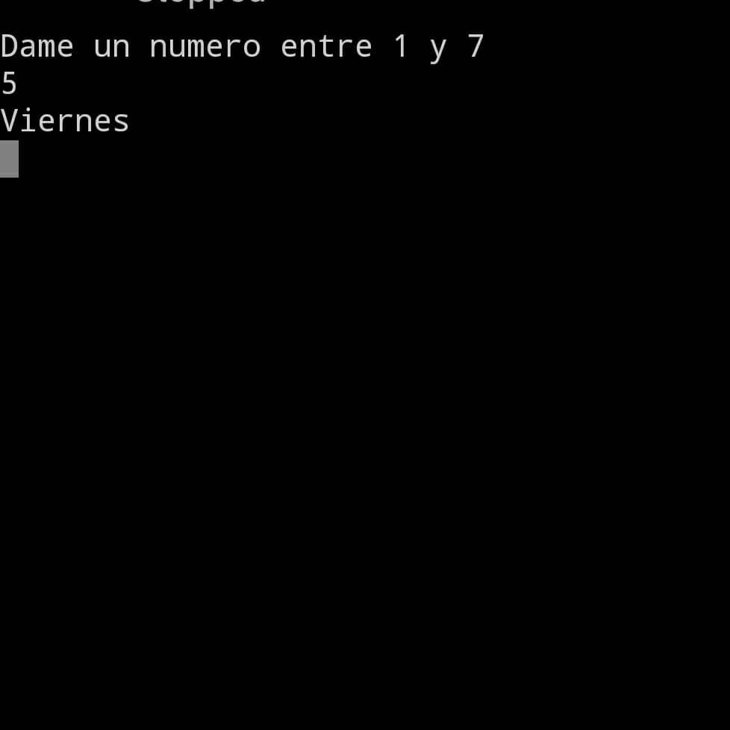

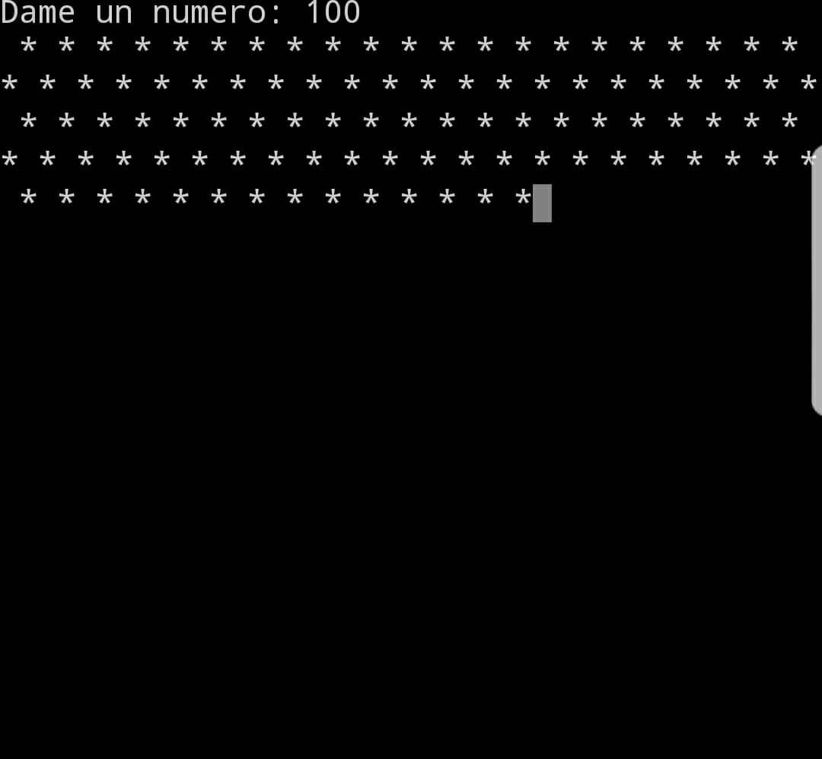

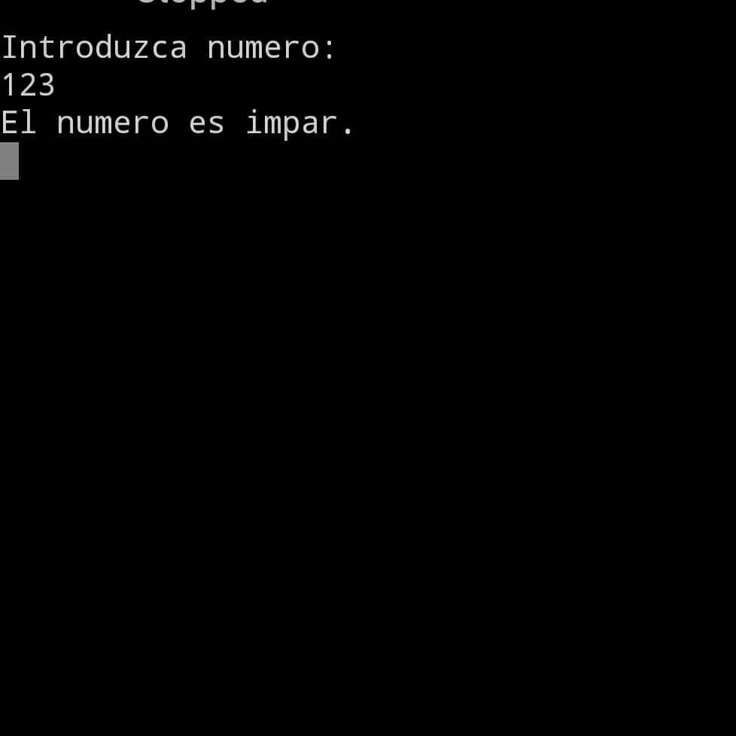

Link de github: https://github.com/Jaimeortegaibarra/Computadoras-Y-Programaci-n-2018-/blob/master/Tarea%209